**GMAPS**

](https://soundcloud.com/user-879892202)

**Dynamics**

**& Kinematics**

**Worksheet**

**To see the additional comments and resources, make sure you select All Markup in the Review/Tracking pane**

It makes sense to use Unity’s physics engine for much of your game development. So why bother to learn how to code physics yourself?

Well, education isn’t just about doing – it’s also about **understanding**.

If you understand how something works, you become much better at using it. When things go wrong, you can solve problems more quickly.

There’s actually a high chance that you might have to write your own physics for some projects.

You’ve already implemented this!



Or maybe you need to calculate the path of a projectile?

[](https://mathematica.stackexchange.com/questions/86255/animating-a-3d-shape-along-path-a-2d-and-3d-parametric-function-curve-update)

As you can guess, it’s all math!

**Some History - Aristotle**

Aristotle was a philosopher in Ancient Greece, born in 384 BC. He is one of the greatest thinkers in human history, influencing Politics, Science and [Philosophy](https://plato.stanford.edu/contents.html) for many centuries.

Aristotle took a very common-sense view of motion, but which turns out to be wrong (like many “common-sense” things in life).

Aristotle thought that heavenly objects (e.g. planets) move forever in circles without any external force acting on them.

He thought that an earthly object will only move when a force is applied to it – and if the force is removed, the object will come to a stop.

Aristotle also believed that when objects were moved by people, this was due to “unnatural force” (e.g. an artificial force). And when the unnatural force ran out (like running out of energy), then “natural” motion would take over again.

[This](https://science.howstuffworks.com/innovation/scientific-experiments/10-things-we-thought-were-true-before-scientific-method9.htm) is how the trajectory of a cannonball was shown in 1561.



Aristotle supposed that it would move in a straight line (due to the unnatural force), and then would fall straight down (due to a different, natural force).

Then along came Isaac Newton, who totally demolished Aristotle.



Aristotle’s views were eventually overthrown by one of the most influential scientists of all time, Isaac Newton, whose Three Laws of Motion are considered to be a correct model of how the universe works.

Isaac Newton was a complete 17th Century rock star scientist – though he had periods of madness when he accused everyone of plotting against him!

We’ll look at Newton’s three laws, and see how these relate to Unity Physics, and how we can implement them ourselves.

**Part 1 : Basic Dynamics & Kinematics**

**Newton’s 1st Law of Motion**

**An object at rest stays at rest and an object in motion stays in motion with the same speed and in the same direction unless acted upon by an unbalanced force.**

This is also called the **Law of Inertia**.

Okay, let’s see how this works in Unity.

Download **03_KINEMATICS_Worksheet.zip** from LMS. Unzip, and add the folder to the **Assets** folder in your worksheets project.

Go to the **Part 1** folder.

The **FirstLaw.cs** script is provided.

Add a **Vector3** public property called **force**, so that the force value applied to the sphere can be set in the Inspector.

In the Start() function, apply force **just once**. Apply different values along X, Y, Z each time you run it to see what happens.

Print out the position of the sphere after every frame.

You should see something like this:

The force was only applied once, in Start().

Does this follow Newton’s First Law? Explain.

In reality, we can’t get away from forces. There’s gravity, air resistance, the wind blowing, and so on. To get away from all those forces we’d have to fly into space.

But in a game, we control what happens. So, the example above simulates a world with no forces acting on an object except for the forces we program.

[](https://phys207-project.physics.wisc.edu/ann-seliger/newtons-1st-law-of-motion/)

Now, create a second sphere called **Ball2** that does *not* have a rigidbody.

Add a script called **Motion.cs** that moves the ball in the same way as **Imp1**, but using just your code and not Unity physics.

Add this code to **FixedUpdate()**.

So far, you’ve just been moving an object by changing its position based on applying a force once, or simply setting the object’s velocity and moving the object based on that. But what about other more complex problems that you might have when developing a game?

One problem you might face is how to make a character jump to a certain height.

We can also solve this using one of the SUVAT equations!

Here’s the basic math for how it’s done:

v*v = u*u + 2as

u*u = v*v - 2as

u = sqrt(v*v - 2as)

So, open the **JumpToHeight** folder, and create a new file called **JumpToHeight.cs**.

Complete the code below to make each cube jump to a different height (each cube’s individual jump height is set by **Height** in the Inspector.

Add this script to each cube in the scene, and set its jump height.

Press the space bar to make the cubes jump.

**Part 2 : Shooting Pool**

Now we’ll figure out how to shoot a pool ball with a pool cue! We’ll do this without using any Unity Physics APIs.

Open **Part 2 Pool** in your **GMAPS_Oct_2023_Worksheets STUDENT** project.

First, we need a class to represent a 2D ball. For now, we’ll create a simple class that responds to the change in velocity caused by interacting with a pool cue.

The pool cue is really just the mouse. We click on the ball, then drag and release the mouse to set the ball’s velocity. The black line below is the “pool cue”, which we’ll draw as we drag the mouse.

So, to create the effect of a pool cue hitting the ball, we must:

* Check if the mouse position is inside the ball
* Draw a line from the mouse to the ball, to represent the ball’s velocity after releasing the mouse.
* Set the velocity of the ball
* Move the ball according to its velocity

1. First, we’ll create a ball prefab.

* Open the **Pool** scene.
* From the **Sprites** folder, drag **ball** into the scene. Make sure its transform is reset to all zeros.

The ball should appear at the bottom left of the table.

* Drag the ball object from the Hierarchy into the Prefabs folder.
* Drag the ball so that it sits somewhere near the centre of the table. Rotate the camera around a bit. You might find that the ball isn’t visible from some angles.
* This is due to the order of the ball sprite in the rendering layer.

See if you can figure out how to fix this so that the ball is always visible above the table (hint, check the ball’s **SpriteRenderer** component).

Ok, the ball game object is in place. Now to create the script.

* Create a C# script called **Ball2D.cs**. Add this script to the ball prefab. If you’ve done it correctly, you should see the script as a component on the ball object in the scene.

We need to keep track of the ball’s *position* and *velocity*. Both of these will be represented as 2D vectors, using **HVector2D**.

* In Ball2D, declare two public variables called **Position** and **Velocity**. Set them to be new HVector2D objects with x=0 and y=0.



Set the actual Position.x and Position.y values in Start.

* Declare a public float variable called **Radius**.

To set the value of Radius, we need to know the sprite size. Add this code to the Start function:

This should be fairly obvious, apart from the **pixelsPerUnit** property.

In the last line, since the sprite is square shaped, we can just divide the x value (which is the sprite’s width) by 2 to get the radius of the ball.

We now have a ball object in the scene, with a Ball2D script attached to it.

1. In the diagram below, we see that if the distance from the ball’s centre position to the mouse is *less than or equal to the ball’s radius*, then the mouse position is *inside the ball*.

How to calculate the distance from the ball’s centre position to the mouse position?

One way would be to create a vector from the ball to the mouse, and then calculate the vector’s magnitude. But that would require creating a new object, when all we need is a simple mathematical calculation.

The diagram below should help you figure it out using basic trigonometry.

We’ll write a function to do this. But finding the distance between two objects isn’t really part of any specific object’s functionality, so we’ll create a general *utility* script for this.

Create a class called **Util.cs**. Add a static function called **FindDistance**, as shown below. Complete the missing code.

A static function applies at the class level. So, to calculate the distance between two HVector2D objects, we write:

Test your code to make sure it works properly!

1. A picture containing text

   Description automatically generatedNow to check if the mouse position is inside the ball. Another way of saying “inside the ball” is ***colliding*** with the ball. So, we’ll write a function in Ball2D called **IsCollidingWith**, as shown below.

Complete the missing code.

1. To check if the mouse position is inside the ball, we make use of our answers to (a) and (b).

Where should we put this code, though?

Inside Ball2D?

But checking if the mouse is inside the ball is really part of the pool cue’s functionality.

So we should create a new class called **PoolCue.cs** and put the code in there.

Add this script to the **PoolCue** object in the scene.

The **LineFactory** and **Ball** objects in the scene should be dragged into the relevant slots in the Inspector.

**🡪 IMPORTANT!** Run the game. What happens? The line keeps getting drawn even after the mouse is released! How to fix this? Basically, you also need to check if the mouse button is up. If it is, disable line drawing and set the **drawnLine** object to null.

Do that now.

Okay, we’ve solved the first two problems:



* Check if the mouse position is inside the ball
* Draw a line from the mouse to the ball, to represent the ball’s velocity after releasing the mouse.

Now for the other two:

* Set the velocity of the ball
* Move the ball according to its velocity

1. The **Ball2D** script has a **Velocity** property. We need to set this to the correct value to make the ball object move.

This velocity value is set when we release the mouse while drawing the cue. The velocity is actually the vector from the mouseup position to the ball position. So, we need to set this velocity value when the mouse is released. Where in your code is this done?

Add this line of code somewhere in PoolCue.cs.



Run the game. Print out the ball’s velocity. Does the ball move? Nope! We still have to add that code to the Ball2D class.

1. Add this code to **Ball2D**.

It’s always good practice to separate your code into specific functions. In this case, we define a function for updating the ball’s physics.

* Text

  Description automatically generated with medium confidenceComplete the physics code below.

You can now move the ball by using only the mouse as a pool cue and your knowledge of Newtonian dynamics and kinematics!

**PART 3: Reflection**

1. What was the most difficult part of this worksheet. Explain why you found it difficult, and how you managed to overcome this (if at all).

Answer:

I found Game Imp 4 Part (d) to be the most difficult part for me.

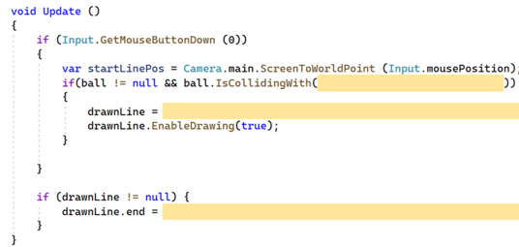

This is mostly due to me forgetting about how LineFactory works and failing to implement the proper API needed to draw a line. I managed to overcome this by going back to my Vector Worksheet and revising what I did for drawing lines.

Another part of the worksheet which was took me sometime to understand was Game Imp 4 Part (e).



When I was hitting the ball, it was sent into another direction. This was due to my value ‘v’ being wrong. How I initially solved it was by setting my input of my mouse position to be the new HVector2D into the world scale. This was wrong because this vector did not provide the appropriate direction and magnitude.

How I overcame this was by realising this and figuring out a way for me to obtain the direction vector of the line and using that as my ‘v’ value. How I did this was by getting ‘drawnLine.start’ as my end point and ‘drawnLine.end’ as my start point. At first, I had I got the direction vector wrong as the naming conventions of these vectors confused me.

However, after some thought I realised that the start of the line, where my cursor clicked on the ball, was the end point for the vector I wanted to obtain and vice versa with the start point for the direction vector I wanted. After I implemented these values, the ball when hit was going in the expected direction and the velocity of the ball was appropriate.

*You might like to reference specific lecture slides and lines of code, give some URLs and diagrams as references, etc.*

(Min 150 words)

1. Choose a kinematics and dynamics topic that are you still unsure about. Explain that topic, and the steps you will take to clarify your doubts. You will be graded on how well you analyse your problem with understanding that topic.

If you are confident about all the topics, select what you consider to be the most difficult topic and explain ONE more advanced concept related to the topic. You will be graded on the complexity of the concept, and how well you explain it.

Answer:

One topic I am still unsure about is the semi-implicit Euler method. What I understand about the method is that it is used to determine an object’s position over time. However, I do not really understand how the method itself calculates the position and how the values work together to find the final position.

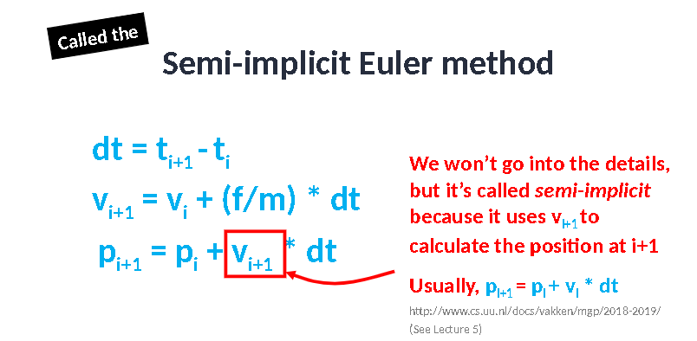

To understand it better, I would probably start by looking up basic explanations of how each value works together and how deltaTime affects these values to produce the object’s position.

Then, I would look for simple examples or tutorials that walk through how this method is applied. I might also ask someone who knows more about math or physics for help from either my lecturer or my friends, as I'm not confident in my understanding of these concepts.

Overall, I need to break down the semi-implicit Euler method into simpler steps and examples to make sense of it as well as doing questions for applying the knowledge from my research.

*You might like to reference specific lecture slides and lines of code, give some URLs and diagrams as references, etc.*

(Min 150 words)

1. Write a reflection about this worksheet. You may like to include how effective it is to motivate and help you learn, how well it relates to games development, etc.

Answer:

To reflect on the worksheet, I have not really experienced much trouble with most of the worksheet, other than what I have mentioned before, and most of the questions are easy to understand and implement from our notes such as the lecture slides for Kinematics & Dynamics.

For my feedback, I think it would be helpful for students to also put a note on how LineFactory works on the side as a hint. I have seen these notes to help guide my way of thinking and I believe doing this for concepts we have not applied for some time may help refresh our memory and get an idea of where to start coding.

The questions given are applicable to what I do in my game development projects for other subjects such as Programming with Game Engines (PGGE) and Game Development Project (GDP). An example of this was during my PGGE project where I had to calculate the range between two objects and the some of the concepts that I learnt here could better improve my understanding on that topic. Overall, it is relevant to what we use in game development.

(Min 150 words)